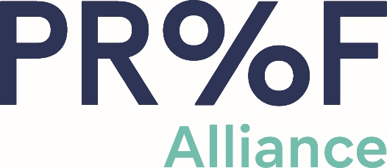 | 2021-2022  College Ambassador Program  Final Narrative Report

Organization:
Event Name:
Date:
Location:

Summarize your event, including format of the event, any speakers involved, etc.

How did you incorporate education on the Proof Alliance prevention message, the importance of preconception health, and the risks associated with alcohol use during pregnancy?

What activities/games did you utilize at your event?

How did you evaluate your event? Please share results of the evaluation.
How did you promote your event?

Did you utilize social media in your promotion? If so, please describe your online marketing efforts.

What do you believe made your event successful, and how was that reflected in the outcome? How do you measure the success of your event?

What do you believe were challenges in hosting your event? How did you try to mitigate them?

Was a planning committee involved in the implementation of this event? If so, please list names, titles and organizations of all involved, and indicate how often the committee met.

Measuring Impact
Measurement | Expected # Reached | Actual # Reached
Total Attendees
Social Media Reach

Demographic Category Reached | Place an X by those you expect to reach | Place an X by those you actually reach
Race/Ethnicity
American Indian or Alaska Native
Hawaiian or Other Pacific Islander
Asian or Asian American
Black or African American
Hispanic or Latinx
Non-Hispanic White
Unknown
Age
Under 18
18-24
25-34
35-44
45-54
55-64
65 and over
Unknown
Identified Gender
Female
Male
Transgender
Gender Non-Conforming
Unknown
Pregnancy Status
Pregnant
Not Pregnant
Unknown

***** Please attach photos from your event to this report *****

